OBS VERİ TABANI

--SİSTEMDE BİR OBS VERİ TABANİ MEVCUTTUR. BU VERİ TABANİNA İLİSKİN SORGULAR ASAGIDA

LİSTELENECEKTİR.

--TABLOLARİ LİSTELEME

SELECT * FROM class

SELECT * FROM department

SELECT * FROM lecturers

SELECT * FROM lesson

SELECT * FROM note

SELECT * FROM pass_status

SELECT * FROM register

SELECT * FROM student

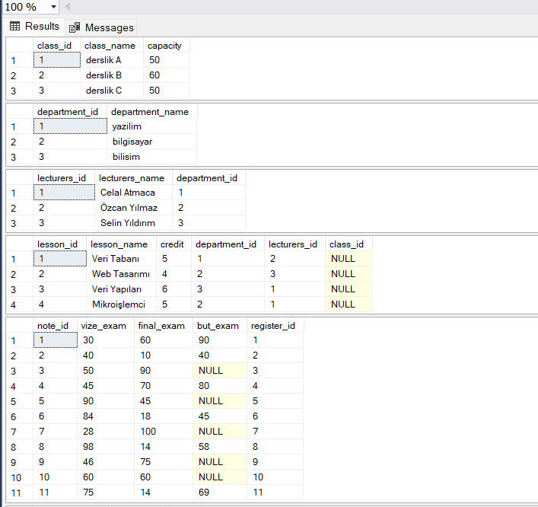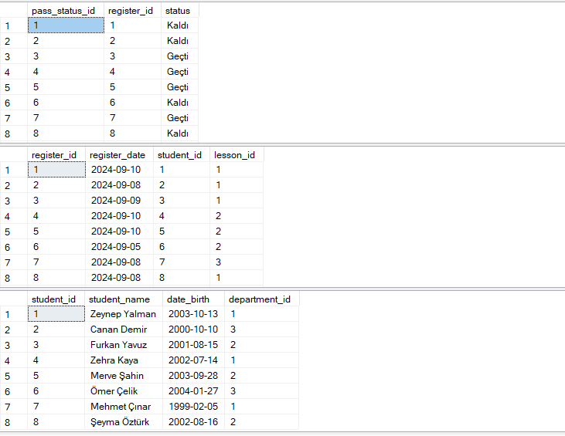

--OGRENCİ TABLOSUNDA ADİ Z C VE M HARFİ İLE BASLAYANLARIN LİSTESİ

SELECT * FROM student where student_name like '[ZCM]%'

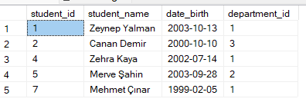

--ogrenci tablosunda dogum tarihi verilen araliklarda olan ogrencileri sırala

SELECT * FROM student

where date_birth between '01/01/2000' and '12/31/2002'

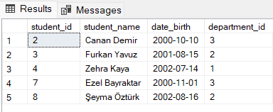

--ogrenci tablosunda kac farkli isim var

SELECT count(distinct student_name) as farkli_isim_sayisi from student



- herhangi bir dersten kalan ögrencileri verir. join islemi ile ogrenci, ders kaydi, dersten gecme, ders, bolum tablolari birlestirildi*

SELECT s.student_id, s.student_name,p.status,d.department_name,les.lesson_name,les.lecturers_id

FROM student s

JOIN pass_status p ON s.student_id = p.pass_status_id

JOIN register r ON r.register_id=p.pass_status_id

JOIN department d ON s.student_id=d.department_id

JOIN lesson les ON les.lesson_id=d.department_id

WHERE p.status = 'Kaldı'

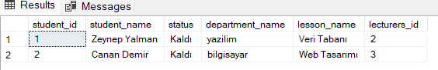

--silinen öğrencinin adını soyadını mezun tablosuna trigger ile kaydediyoruz. foreign keyler oldugu icin bagli oldugu diger tablolardan da silinmesi gerekiyor.

create table graduate(graduate_name varchar(50))

ALTER TRIGGER delete_student

ON student

INSTEAD OF DELETE

AS

BEGIN

-- Silinen öğrenci bilgilerini geçici bir tabloya kopyalayın

DECLARE @deleted TABLE (student_id INT, student_name VARCHAR(50));

INSERT INTO @deleted (student_id, student_name)

SELECT student_id, student_name

FROM deleted;

-- pass_status tablosundaki ilgili kayıtları siliyoruz

DELETE FROM pass_status

WHERE register_id IN (SELECT register_id FROM register WHERE student_id IN (SELECT student_id FROM @deleted));

-- not tablosundaki ilgili kayıtları siliyoruz

DELETE FROM note

WHERE register_id IN (SELECT register_id FROM register WHERE student_id IN (SELECT student_id FROM @deleted));

-- register tablosundaki ilgili kayıtları siliyoruz

DELETE FROM register

WHERE student_id IN (SELECT student_id FROM @deleted);

-- Silinen öğrencinin adını graduate tablosuna ekliyoruz

INSERT INTO graduate (graduate_name)

SELECT student_name

FROM @deleted;

-- Öğrenciyi student tablosundan siliyoruz

DELETE FROM student

WHERE student_id IN (SELECT student_id FROM @deleted);

END;

DELETE FROM student WHERE student_id =7 --silinmek istenen ögrencinin id si girilerek islem gerceklestiriliyor.

SELECT * FROM student

select * from graduate

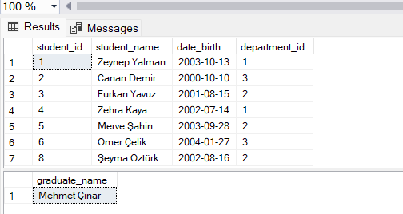

--vize notu 50den fazla olan ogrencileri sirala

SELECT s.student_id, s.student_name,p.status,n.vize_exam

FROM student s

JOIN pass_status p ON s.student_id = p.pass_status_id

JOIN register r ON r.register_id=p.pass_status_id

JOIN note n ON r.register_id=n.note_id

WHERE n.vize_exam >50

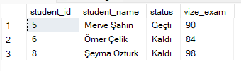

--7. indexe yeni ögrenci atandı

INSERT INTO student(student_id,student_name, date_birth, department_id)

VALUES(7,'Ezel Bayraktar', '2000-11-01' , 3)

select *from student

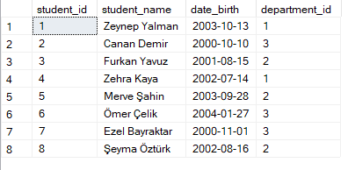

--ogrenci adi ile butunleme notu guncellendi

UPDATE note

SET but_exam = 99WHERE register_id IN (

SELECT register_id

FROM register

WHERE student_id IN (

SELECT student_id

FROM student

WHERE student_name = 'Canan Demir' )

);

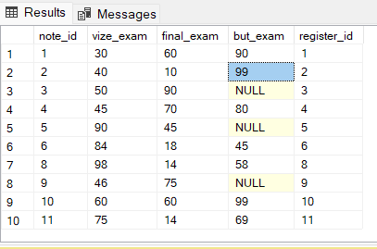

--ogrenci kaydini daha efektif hale getirmek icin bir stored procedure yazalim

CREATE PROCEDURE Addstudent

@student_id INT,

@student_name NVARCHAR(100),

@date_birth DATE,

@department_id INT

AS

BEGIN

-- INSERT işlemi

INSERT INTO student (student_id, student_name, date_birth, department_id)

VALUES (@student_id, @student_name, @date_birth, @department_id);

END;

GO

-- Stored procedure'u çagırma

EXEC Addstudent

@student_id = 9,

@student_name = 'Nurgül Kızmaz',

@date_birth = '1999-02-18',

@department_id = 1;

select *from student

